SEG 2105 Assignment 5

Create a document outlining your work with the following information:

1. The client wants an email application that permits users to send, receive and delete emails.
2. A user must have a name, a login ID, an in and outbox.  
   A server must have a host and port number.  
   An email must have a title, a sender, a destination address, some content, a date, and is part of a conversation.
3. A user can compose an email and send it to either themselves, someone else or all users on the server.  
   A user can ask the server to send them the contents of their inbox or outbox.  
   A user can decide to delete an email from their inbox.  
   A user can login and logout.  
   The server can send messages when it deems it appropriate.
4. We will create the application using the OCSF framework, re-use our simple chat application, and code in Java.   
   The client will perform lightweight tasks and asking the server to do all the work.
5. http://cruise.eecs.uottawa.ca/umpleonline/?text=class%20Server%7B%0A%20%20Integer%20port%3B%0A%20%20String%20host%3B%0A%7D%0A%0Aclass%20Email%7B%0A%20%20String%20title%3B%0A%20%20String%20content%3B%0A%20%20Date%20date%3B%0A%7D%0A%0Aclass%20Client%7B%0A%20%20String%20name%3B%0A%20%20String%20loginID%3B%0A%20%201%20--%202..*%20Mailbox%3B%0A%20%20*%20--%201%20Server%3B%0A%7D%0A%0Aclass%20Mailbox%7B%0A%20%20%0A%20%20*%20--%20*%20Email%3B%0A%7D%0A%0Aclass%20Inbox%7B%20%20isA%20Mailbox%3B%0A%7D%0Aclass%20Outbox%7B%20%20isA%20Mailbox%3B%0A%7D%2F%2F%24%3F%5BEnd_of_model%5D%24%3F%0A%0Aclass%20Outbox%0A%7B%0A%20%20position%20208%20429%20109%2045%3B%0A%7D%0A%0Aclass%20Client%0A%7B%0A%20%20position%20236%2029%20119%2080%3B%0A%20%20position.association%20Client__Mailbox%205%2C80%2030%2C0%3B%0A%7D%0A%0Aclass%20Mailbox%0A%7B%0A%20%20position%20223%20161%20109%2045%3B%0A%7D

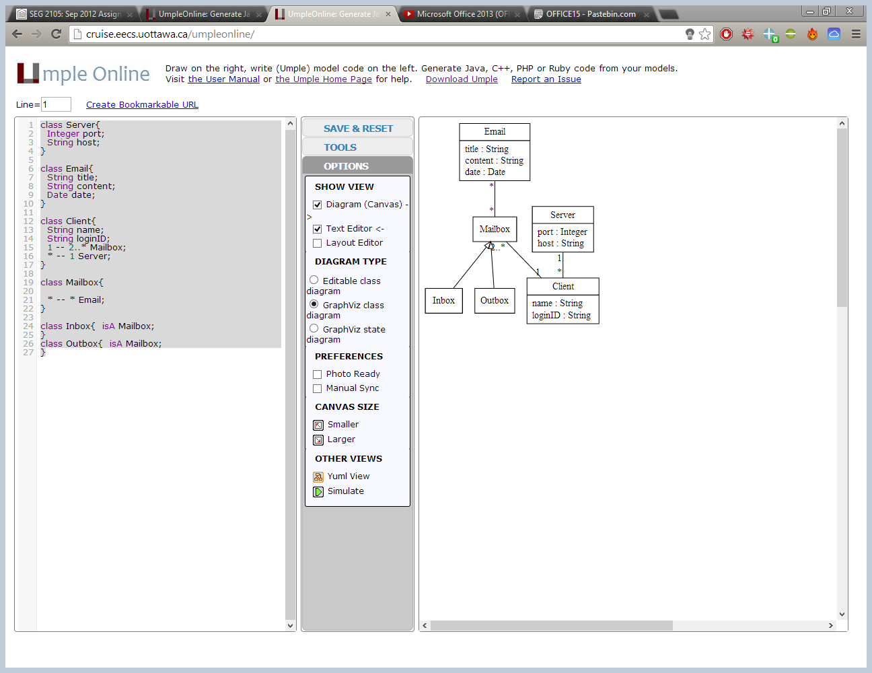

class Server{  
 Integer port;  
 String host; }

class Email{  
 String title;  
 String content;  
 Date date; }

class Client{  
 String name;  
 String loginID;  
 1 -- 2..* Mailbox;  
 * -- 1 Server; }

class Mailbox{  
 * -- * Email; }

class Inbox{ isA Mailbox; }

class Outbox{ isA Mailbox; }

1. We plan to use a UI to make it easier for the user to send and receive messages. A display method will also make reading a message easier.  
     
   #send @<author> @<destination> @<title> @<content> @<date>  
   Message sent.  
     
   #getmessages <integer>  
   - No new messages.  
   @<author> @<destination> @<title> @<content> @<date>  
     
   #delete @<title> @<date>  
   Message deleted.  
     
   #login   
   Welcome back, <loginID>

#logout  
Come back soon!  
Logged out.